***Chemistry***

**6: Electronic Structure and Periodic Properties of Elements**

**6.3: Development of Quantum Theory**

31. How are the Bohr model and the quantum mechanical model of the hydrogen atom similar? How are they different?

Solution

Both models have a central positively charged nucleus with electrons moving about the nucleus in accordance with the Coulomb electrostatic potential. The Bohr model *assumes* that the electrons move in circular orbits that have quantized energies, angular momentum, and radii that are specified by a single quantum number, *n* = 1,2,3,…, but this quantization is an ad hoc assumption made by Bohr to incorporate quantization into an essentially classical mechanics description of the atom. Bohr also assumed that electrons orbiting the nucleus normally do not emit or absorb electromagnetic radiation, but do so when the electron switches to a different orbit. In the quantum mechanical model, the electrons do not move in precise orbits (such orbits violate the Heisenberg uncertainty principle) and, instead, a probabilistic interpretation of the electron’s position at any given instant is used, with a mathematical function *ψ* called a wave function that can be used to determine the electron’s spatial probability distribution. These wave functions, or orbitals, are three-dimensional stationary waves that can be specified by three quantum numbers that arise naturally from their underlying mathematics (no ad hoc assumptions required): the principal quantum number, *n* (the same one used by Bohr), which specifies shells such that orbitals having the same *n* all have the same energy and approximately the same spatial extent; the angular momentum quantum number *l*, which is a measure of the orbital’s angular momentum and corresponds to the orbitals’ general shapes, as well as specifying subshells such that orbitals having the same *l* (and *n*) all have the same energy; and the orientation quantum number *m*, which is a measure of the *z* component of the angular momentum and corresponds to the orientations of the orbitals. The Bohr model gives the same expression for the energy as the quantum mechanical expression and, hence, both properly account for hydrogen’s discrete spectrum (an example of getting the right answers for the wrong reasons, something that many chemistry students can sympathize with), but gives the wrong expression for the angular momentum (Bohr orbits necessarily all have non-zero angular momentum, but some quantum orbitals [*s* orbitals] can have zero angular momentum).

33. Describe the properties of an electron associated with each of the following four quantum numbers: *n*, *l*, *ml*, and *ms*.

Solution

*n* determines the general range for the value of energy and the probable distances that the electron can be from the nucleus. *l* determines the shape of the orbital. *m1* determines the orientation of the orbitals of the same *l* value with respect to one another. *ms* determines the spin of an electron.

35. Identify the subshell in which electrons with the following quantum numbers are found:

(a) *n* = 2, *l* = 1

(b) *n* = 4, *l* = 2

(c) *n* = 6, *l* = 0

Solution

(a) 2*p*, (b) 4*d*, (c) 6*s*

37. Identify the subshell in which electrons with the following quantum numbers are found:

(a) *n* = 3, *l* = 2

(b) *n* = 1, *l* = 0

(c) *n* = 4, *l* = 3

Solution

(a) 3*d;* (b) 1*s;* (c) 4*f*

39. Sketch the boundary surface of a  and a *py* orbital. Be sure to show and label the axes.

Solution

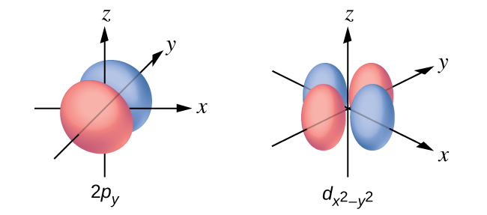

41. Consider the orbitals shown here in outline.

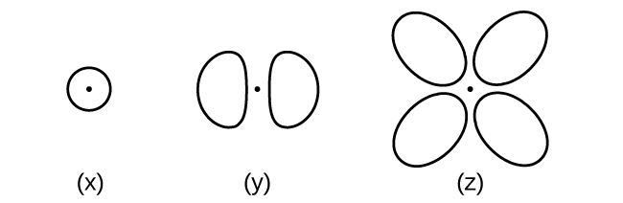

(a) What is the maximum number of electrons contained in an orbital of type (x)? Of type (y)? Of type (z)?

(b) How many orbitals of type (x) are found in a shell with *n* = 2? How many of type (y)? How many of type (z)?

(c) Write a set of quantum numbers for an electron in an orbital of type (x) in a shell with *n* = 4. Of an orbital of type (y) in a shell with *n* = 2. Of an orbital of type (z) in a shell with *n* = 3.

(d) What is the smallest possible *n* value for an orbital of type (x)? Of type (y)? Of type (z)?

(e) What are the possible *l* and *ml* values for an orbital of type (x)? Of type (y)? Of type (z)?

Solution

(a) x. 2, y. 2, z. 2; (b) x. 1, y. 3, z. 0; (c) x. 4 0 0 , y. 2 1 0 , z. 3 2 0 ; (d) x. 1, y. 2, z. 3; (e) x. *l* = 0, *ml* = 0, y. *l* = 1, *ml =* –1 0 or *+*1, z. *l* = 2, *ml* = –2 –1 0 +1 +2

43. How many electrons could be held in the second shell of an atom if the spin quantum number *ms* could have three values instead of just two? (Hint: Consider the Pauli exclusion principle.)

Solution

In the second subshell (*n* = 2), there are two possible angular momentum (*l*) values (0 and 1). When *l* = 0, the magnetic quantum number (*ml*) can only be 0. When *l* = 1, the magnetic quantum number (*ml*) can be equal to –1, 0, or 1. Therefore, in the second shell, there are four orbitals (the number of orbitals in a shell is equal to *n*2). If there were three possible values for the spin quantum number, each orbital could hold three different electrons and still obey the Pauli exclusion principle. In other words, each orbital could hold three electrons and none of those three electrons would have the exact same four quantum numbers. If each orbital could hold three electrons, the second shell, which has four orbitals, could hold a total of 12 electrons.

45. Write a set of quantum numbers for each of the electrons with an *n* of 4 in a Se atom.

Solution

|  |  |  |  |
| --- | --- | --- | --- |
| *n* | *l* | *ml* | *s* |
| 4 | 0 | 0 |  |
| 4 | 0 | 0 |  |
| 4 | 1 | −1 |  |
| 4 | 1 | 0 |  |
| 4 | 1 | +1 |  |
| 4 | 1 | −1 |  |

This resource file is copyright 2015, Rice University. All Rights Reserved.